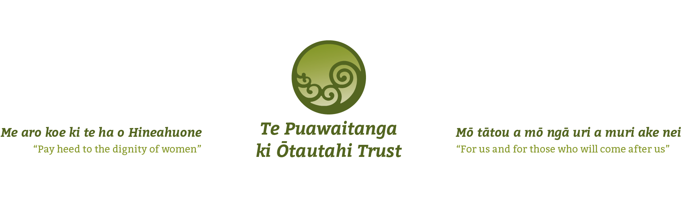

Position Application Form

Thank you for your interest in the Maternal and Infant Mental Health Clinician, with the Whānau Whakapuawai Services.

Please return the completed application form, with your CV and covering letter and the police vetting check form completed to recruitment@omwwl.maori.nz 10am Friday 17th November 2023.

The information you provide on this application form is collected for the purpose of assessing your suitability for employment with Te Puawaitanga ki Ōtautahi Trust. If your application is successful, this form will be retained on your personnel file. If unsuccessful it, along with your other application papers, will be destroyed.

Position applying for:
Name:
Residential Address:
Phone Number:
Email Address:

Eligibility for Employment in New Zealand
Do you have the legal right to work in New Zealand? Yes No

Drivers Licence
Please state the type of drivers licence you have and whether you have any restrictions on your licence

Health
Are you currently undergoing any medical treatment, taking any medication, or recovering from any recent illness or surgery that may affect your ability to effectively carry out the functions and responsibilities of the position? This includes any stress related conditions (e.g., depression, work-related stress?) If yes, please explain.

Yes No

Do you suffer from any physical impairment such as gradual process injury (e.g., occupational overuse syndrome, repetitive strain injury, noise-induced hearing loss or other occupational disease or back injury) to such a degree that it is likely to affect your ability to effectively carry out the functions and responsibilities of the position applied for? If yes, please explain.

Yes No

Would you require any assistance or special facilities to effectively carry out the functions and responsibilities of the position? If yes, please explain.

Yes No

Taking everything into account, is your health good enough to enable you to function effectively without putting yourself or your colleagues at risk? If NO, then please explain.

Yes No

Do you smoke or vape? Yes No

Safe to work with whānau and children
A criminal convictions check will be undertaken as part of your application, if you expect this check to identify criminal convictions, please list these below. Failure to identify convictions might jeopardise your application.

Suitability for Work
Are there any personal reasons that may prevent you from undertaking the tasks of this role?

Are there any professional reasons that may prevent you from undertaking the tasks of this role?

Please indicate your preferred number of working hours each week

Referees
(If your CV includes referees then you do not need to fill in this section)
Please give details of at least two work related referees.

Name | Telephone number(s) | Occupation/Position held

DECLARATION

I, (full name) declare that to the best of my knowledge, the answers to the questions in this application are correct and the information in the attachments are correct. I understand that if any false or misleading information is given, or any material fact suppressed, I may not be accepted, or if I am employed, it may lead to disciplinary action and/or termination of my employment.

Signature Date

Self-Assessment Form
Name: |  | Position applied for: Maternal and Infant Mental Health Clinical Worker Whānau Whakapuawai Service.
Competencies and Experience | Self-Assessment Comments:  - (Please briefly give specific examples of the experience, qualifications, or performance that you think demonstrates the competency)
Collaboration – why is this considered important?
Your view on the relevance of Te Tiriti o Waitangi in today’s world

Share your expertise in working with in mental health care or people experiencing trauma
Whānau Wellbeing – what does this mean to you?

Lived experience of Te Ao Māori
Working in an accountable manner and as a team member

